Project Design Phase
Solution Architecture

Date | 25 September 2026
Team ID | 6ab4bf896f290be8a6b413e7
Project Name | AI WeatherWise API
Maximum Marks | 4 Marks

Solution Architecture:
Solution architecture is a complex process – with many sub-processes – that bridges the gap between business problems and technology solutions. Its goals are to:
- Find the best tech solution to solve existing business problems.
- Describe the structure, characteristics, behavior, and other aspects of the software to project stakeholders.
- Define features, development phases, and solution requirements.
- Provide specifications according to which the solution is defined, managed, and delivered.

Example - Solution Architecture Diagram:

Figure 1: Architecture and data flow of the voice patient diary sample application
Reference: https://aws.amazon.com/blogs/industries/voice-applications-in-clinical-research-powered-by-ai-on-aws-part-1-architecture-and-design-considerations/

Solution Architecture Diagram
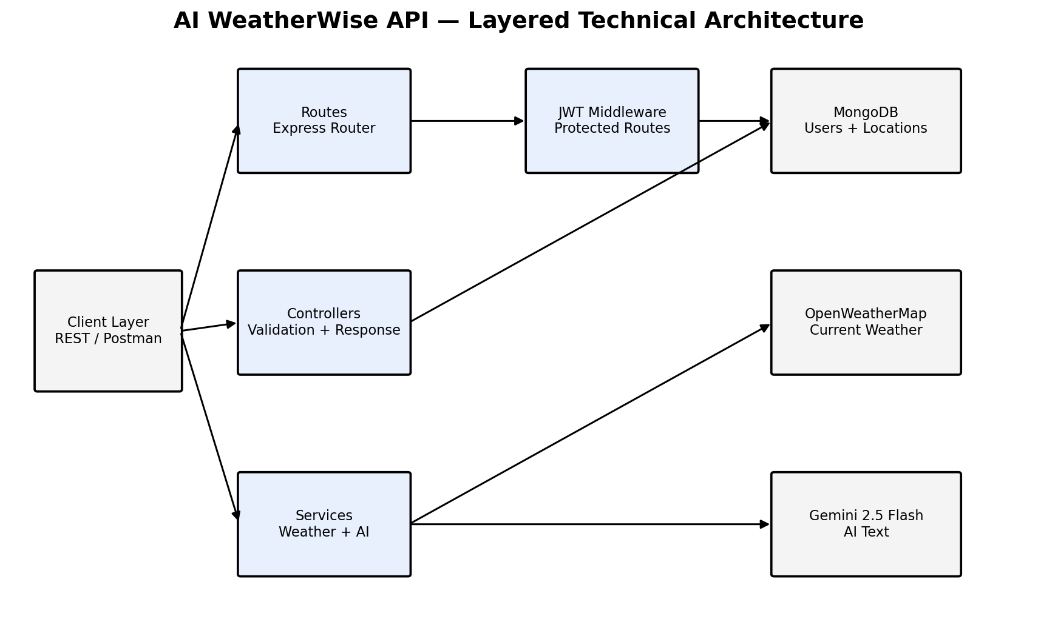
Figure 3: Technical Architecture of the AI WeatherWise API
Request Lifecycle and Fallback Flow
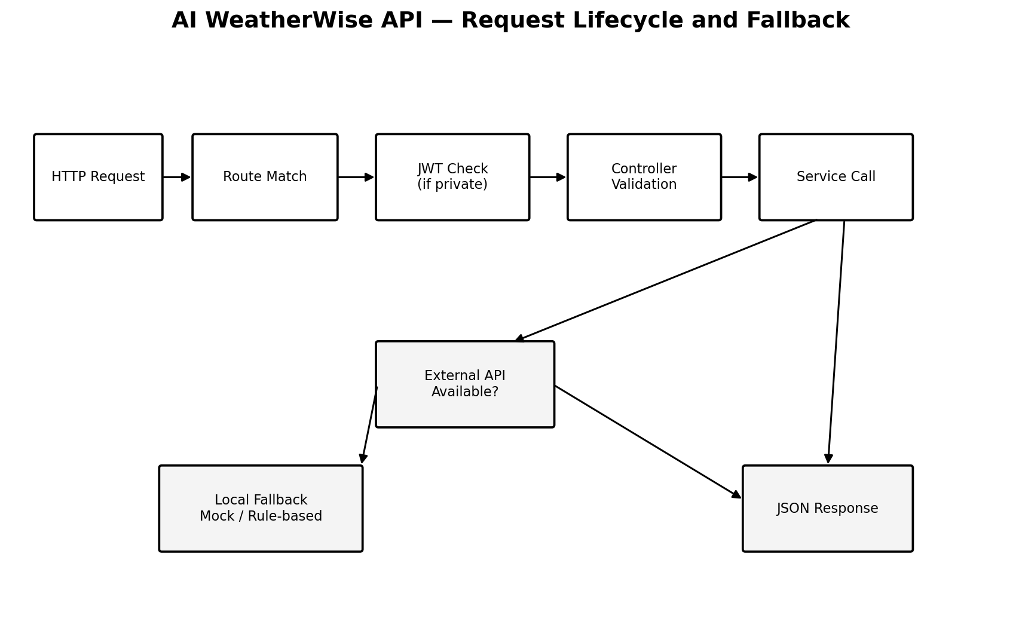
Figure 4: Request Lifecycle and Fallback Flow of the AI WeatherWise API
Table-11: Architecture Layers and Source Files
Table-12: REST API Endpoints
Table-13: User Schema
Table-14: Location Schema
Layer | Files | Responsibility
Entry point | server.js, app.js | Starts the server and the database connection; app.js registers CORS, JSON parsing, the API routes, the 404 handler and the centralized error handler.
Configuration | config/db.js | Connects to MongoDB through Mongoose using MONGO_URI.
Routes | authRoutes.js, locationRoutes.js, weatherRoutes.js, aiRoutes.js | Map the URL paths under /api/auth, /api/locations, /api/weather and /api/ai to the controllers.
Middleware | authMiddleware.js | Verifies the JWT Bearer token and attaches the user (without password) to the request.
Controllers | authController.js, locationController.js, weatherController.js, aiController.js | Validate input, call services or models and return JSON responses.
Services | weatherService.js, aiService.js | Call OpenWeatherMap and Google Gemini, and provide the mock and rule-based fallbacks.
Models | User.js, Location.js | Define the schemas, validation, password hashing and unique index.
Endpoint | Method | Access | Request Body | Description
/api/auth/register | POST | Public | { name, email, password } | Register a new user and receive a JWT token.
/api/auth/login | POST | Public | { email, password } | Log in and receive a JWT token.
/api/auth/profile | GET | Private (JWT) | None | Get the logged-in user’s profile.
/api/locations | POST | Private (JWT) | { city, country } | Save a new favourite city.
/api/locations | GET | Private (JWT) | None | Retrieve all saved favourite cities.
/api/locations/:id | PUT | Private (JWT) | { city, country } | Update a favourite city by ID.
/api/locations/:id | DELETE | Private (JWT) | None | Delete a favourite city by ID.
/api/weather/:city | GET | Public | None | Return current weather metrics for a city.
/api/ai/weather-summary | POST | Private (JWT) | { city, temperature, humidity, condition } | Generate a natural-language weather summary.
/api/ai/weather-recommendation | POST | Private (JWT) | { temperature, condition } | Generate personalised suggestions (clothing, activities).
Field | Type | Constraints
name | String | Required; trimmed.
email | String | Required; unique; trimmed; converted to lowercase; validated with a regular expression.
password | String | Required; minimum 6 characters; hashed with bcrypt (10 salt rounds) in a pre-save hook.
createdAt, updatedAt | Date | Added automatically through timestamps.
Field | Type | Constraints
city | String | Required; trimmed.
country | String | Required; trimmed.
user | ObjectId | Required; reference to the User collection.
createdAt, updatedAt | Date | Added automatically through timestamps.
Index | – | Compound unique index on user, city and country.

